Young People

Persons aged 12 to 25 years are counted here as young people, as this range best matches the age span of those assisted by most youth service providers. In some instances though, other ages are specified, either to match the structure of the available data or because an alternative range is more suitable.
Population
The accompanying map illustrates the geographic distribution of young people (aged 15-24) across Melbourne, with darker shaded areas representing high proportions of young people among the population.
Percentage of Population who are Young People (aged 15 to 24 years): metropolitan Melbourne, 2016

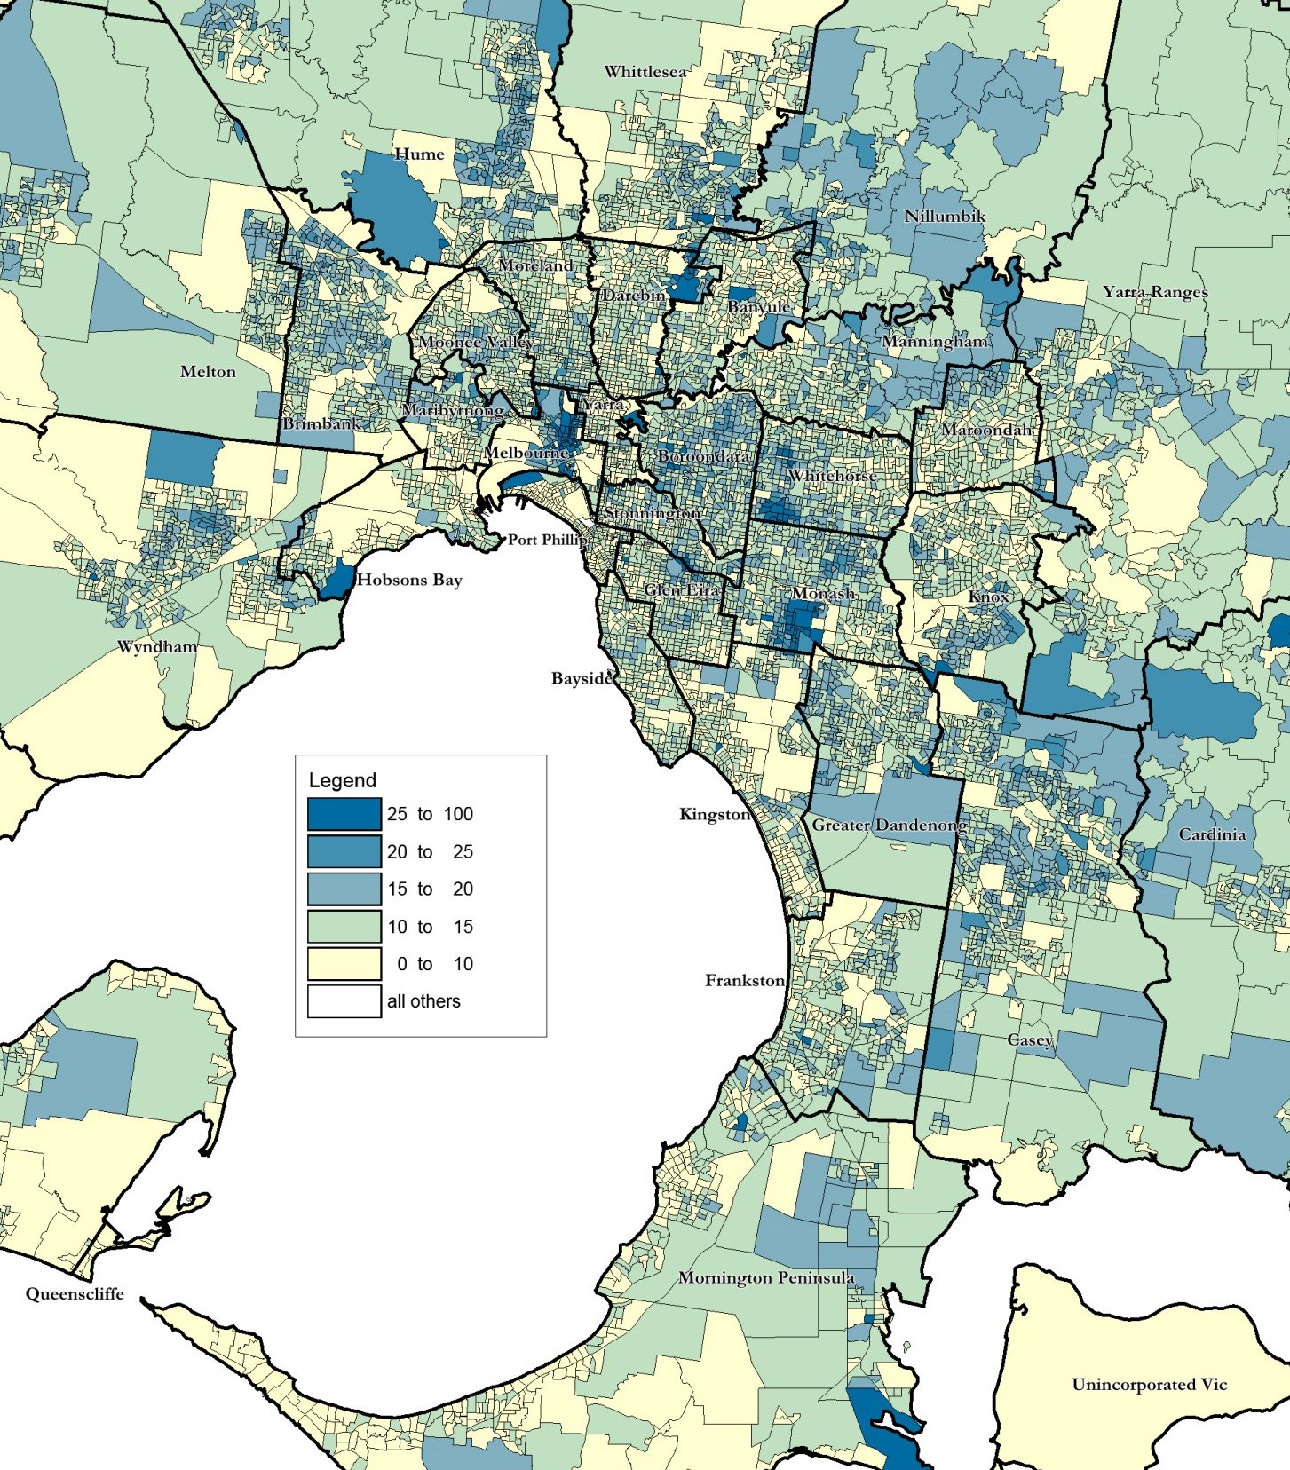
In 2021, nearly 31,000 residents in Greater Dandenong were aged 12-25 years, representing approximately one in six residents. The findings of the 2016 Census indicate that about 130 young people were Aboriginal or Torres Strait Islanders.
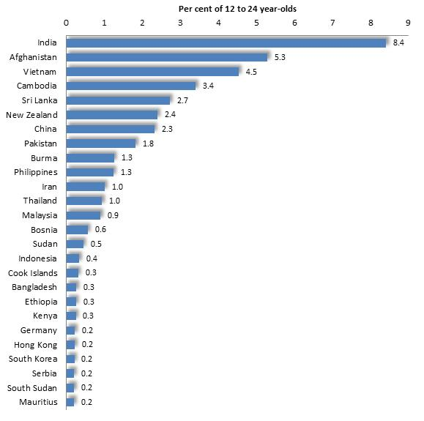
Cultural Diversity
In 2016, just over half (50.1%) of Greater Dandenong residents aged 12-25 were born overseas. They come from 104 different birthplaces, including India, Afghanistan, Vietnam, Cambodia, Sri Lanka, China, Pakistan and Burma.

Birthplaces: persons aged 12 to 24, Greater Dandenong, 2016
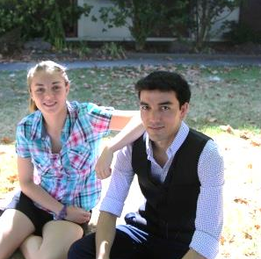

Languages: persons aged 12 to 24, Greater Dandenong, 2016 Spoken Languages & English Fluency
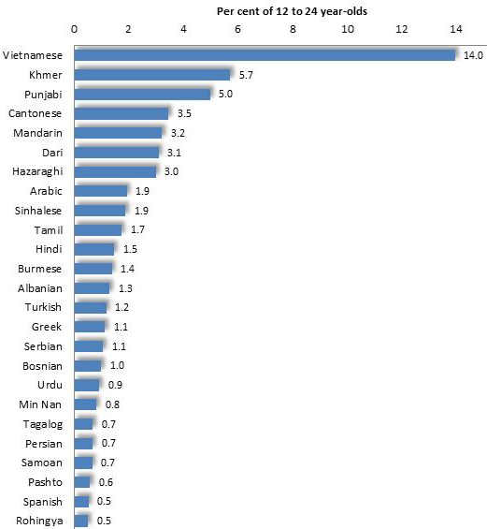
Seventy per cent of 12 to 24 year-olds speak languages other than English at home, including Vietnamese, Khmer, Punjabi, Cantonese, Mandarin, Dari, Hazaraghi and Arabic. By contrast, fewer than a 30% of young people across Melbourne speak languages other than English at home.
Approximately 6% of young people aged 12 to 24 in Greater Dandenong, numbering 1,500, have limited fluency in the use of spoken English. Limited fluency is most widespread among those who speak languages such as Rohingya (62%), Burmese, Pashto, Hazaraghi and Dari. The greater numbers of young people with limited English fluency however, include those who speak Vietnamese, numbering 318, Khmer (208), Hazaraghi (154), Dari (117) and Mandarin (108).
Per cent of 20-24 year-olds who had Left School before
Completing Year 11: Greater Dandenong, 2016 Educational Participation and Outcomes
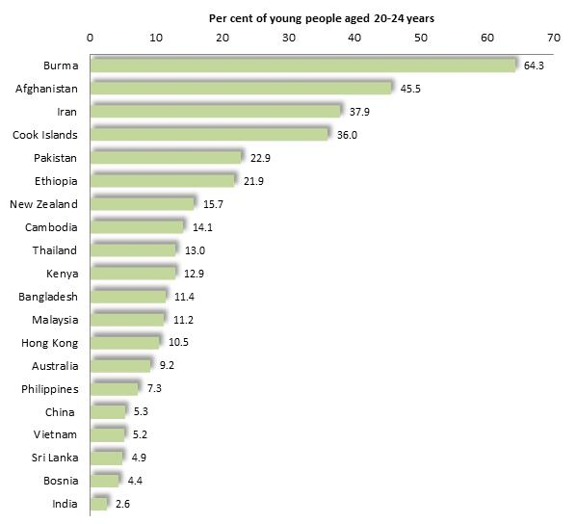
In 2016, 13% of 20 to 24 year-olds in Greater Dandenong had left school before completing year 11 (‘left school early’) - compared with 8.3% across Melbourne.

Two-thirds of those from Burma, and over a third of young adults from Afghanistan, Iran and Cook Islands had left school early, compared with less than one in ten from Australia, and fewer than one in twenty from India, Sri Lanka and Bosnia.

Nearly a third (31%) of 20-24 year-olds in Greater Dandenong were attending university and other tertiary institutions in 2016, compared with 40% of those across Melbourne, though representing a substantial rise from 20% a decade before. By contrast, 10% of young adults of this age were attending TAFE institutions, compared with 6.7% of those across Melbourne.
Disengagement by age and gender: Greater
Youth Disengagement Dandenong and metro. Melbourne 2016
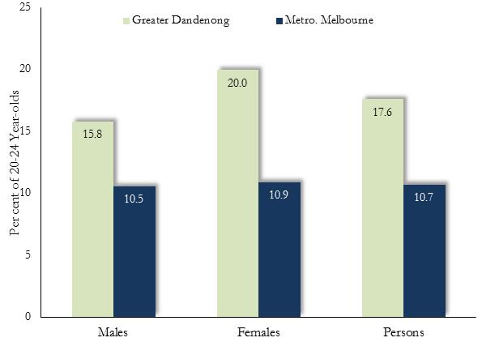
Counting the number of young people who are not in paid work or enrolled in education – termed ‘disengagement’ - gives a balanced measure of the overall educational and economic advancement of young people in the community.
In 2016, the Census found that 2,516 15-24 year-olds in Greater Dandenong were neither employed nor enrolled in education. This represents a rise of 535 or 27% on the number of disengaged young people in Greater Dandenong five years earlier. The proportion of young people who were disengaged rose with age from 6.5% among 15-19 year-olds, to 17.6% among those aged 20-24 years.
Disengagement and Gender
In 2016 rates of disengagement among 20-24 year-olds stood at 20% among males and 15.8% among females. The difference is almost entirely due to the high rate of disengagement among young women with children.

Disengagement and Birthplace
The rate of disengagement in Greater Dandenong was 16.2% among Australian-born young people, rising to 30% or more among those from Pakistan, Iran, Sudan and Burma

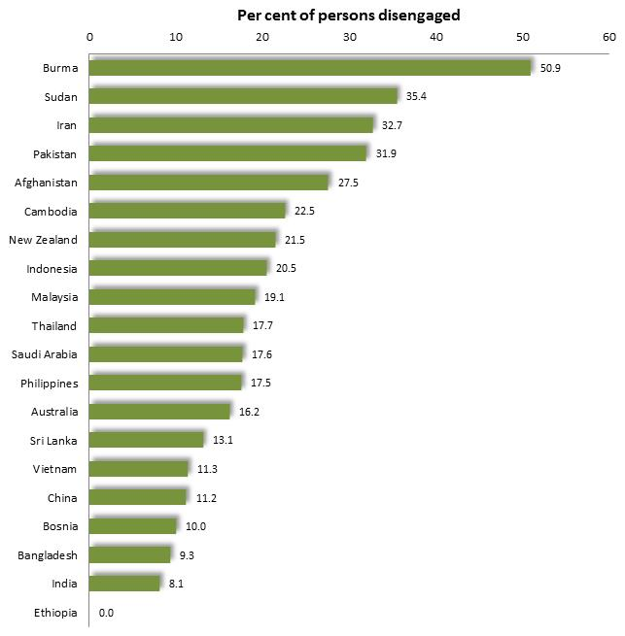
Disengagement rates by birthplace, Greater Dandenong, 2016

Disengagement rates among 20-24 year-olds across metropolitan Melbourne in 2016, are illustrated below. The map highlights the relatively high levels of youth disengagement among localities in the north and west of Melbourne as well as in the south-east.

Percentage of 20 to 24 year-olds who are disengaged: metropolitan Melbourne, 2016
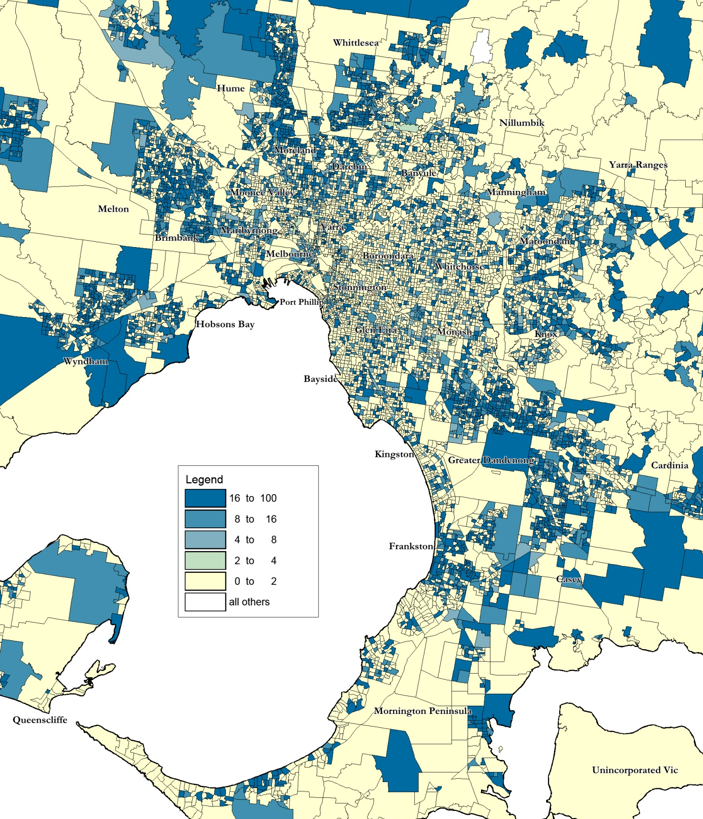

Personal Wellbeing
A 2009 local-level survey of mental health focused upon the wellbeing of adolescents. Published by the Victorian Department of Education and Early Childhood Development in 2012, the survey found that a relatively high proportion of adolescents in Greater Dandenong had experienced unfavorable psychological development, were not satisfied with their lives or had few trusted people in their lives.

Measures of Adolescent Mental Wellbeing: Greater Dandenong and Victoria, 2009
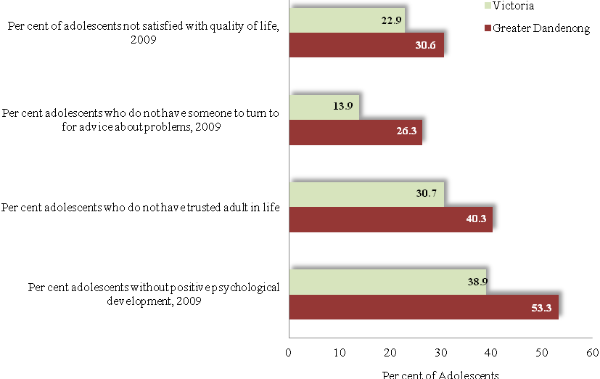

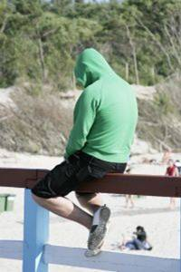

A 2017 survey of young people attending secondary schools in Greater Dandenong found that 23% had very limited personal resilience and a further 41% only ‘fair’ levels of resilience. A third of young people surveyed reported that they felt under constant stress. Among other personal challenges were bullying, motivation to learn, and feeling acknowledged and listened to by adults. (City of Greater Dandenong, 2018).

Births per 1,000 women: Greater Dandenong
Births and metropolitan Melbourne 2018
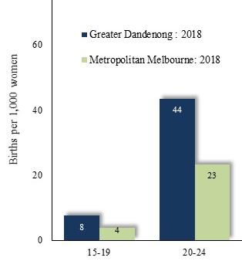
In 2018, 36 births were recorded among women aged 15-19 years in Greater Dandenong, representing 8 births per 1,000 women of that age –double the corresponding metropolitan rate of 4 births per 1,000 women aged 15-19.
Local birth rates among 20-24 year-olds are also relatively high, at 44 per 1,000 women – nearly twice the metropolitan level of 23 per 1,000.

The accompanying map illustrates the high proportions of young women with children in Greater Dandenong and other middle and outer-metropolitan localities, as at 2016.

Percentage of women aged 15 to 24 years who have children: Metropolitan Melbourne, 2016
