USING QGIS

Basic Notes

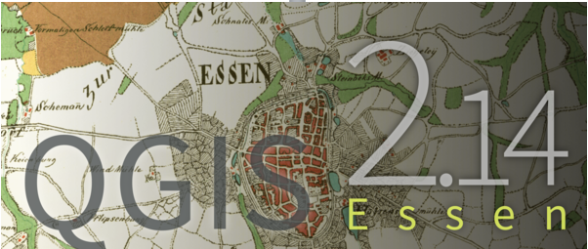

October 25

2018

TABLE OF CONTENTS

Manipulating Images on the Map Canvas 1
Selection 2
Clipping a Layer 5
Layer Control 6
Creating a Layer of Points 8
Creating a Layer of Polygons or Lines 9
Creating a Buffer 10
Layer Properties 12
Attribute Tables 13
Joining Excel to a Map Layer 17
Importing Data with Lat Long Co-ordinates 19
Mapping Attributes 20
Print Composer 22
Setting Parameters 28
Projects 30

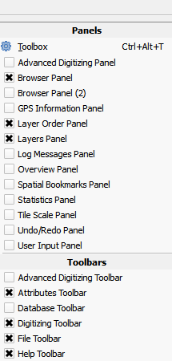
MANIPULATING IMAGES ON THE MAP CANVAS

Viewing Panels (like the layer control) and Toolbars

Right-click on open grey area at upper part of the screen, then select the panel or toolbar to display or close

Or/ View > Panels or View > Toolbars

Map Viewing Tools
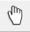 moves map about
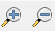 Zoom in & out, or change scale below
Selecting an area with the tool expands that area to fill screen
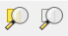 Zoom to selection and to layer
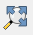 Zooms to view the full, uppermost layer in Layers Panel
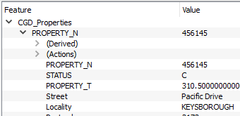
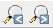 Allows you to toggle through previous or subsequent zooms
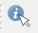 Click then select an area point, to view the fields and corresponding values in its Attribute Table

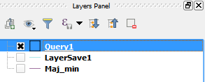
Viewing Attribute Table
Brings up the attribute table for the layer selected in the Layers Panel (right)

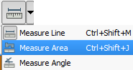
Measuring
Click on measuring icon to measure distance, angle or area.

To measure a line, select ‘measure line’, left-click with mouse on map where you want to commence the measurement, drag mouse, then right-click to end selection of the line.

To measure an area, left-click on map to mark the start point, drag mouse around while holding down left button, left-clicking at each point, then right-click to conclude.

Co-ordinates, Scale and Magnification
These are shown at the bottom of the screen.

Co-ordinates represent the position of the mouse pointer over the map. The co-ordinates can be copied.
Type in co-ordinates, scale or rotation, and the map will change to reflect those values
Co-ordinates illustrated here are in degrees.
The sequence of co-ordinates is: X/longitude/easting , Y/latitude/northing

Co-ordinates can be toggled with Extents, which are the latitude, longitude of the lower-left and upper-right of the screen, respectively

SELECTION – through the map or its attribute table – the result is the same
First, in Layer Frame, activate the layer that you want to select features from
1. Clicking
Selection Tools
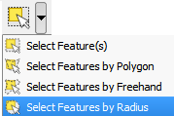
Allows you to choose to select:
- individual features (hold down Control to select more than one area or to unselect a single area),
- by polygon (Right-click to close the polygon),
- by freehand (allows you to carefully select an area within an area),
- and by radius (R-click on map then R-click again to mark centre and start selection

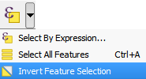 Allows you to select all features of a layer, invert selection or use expression

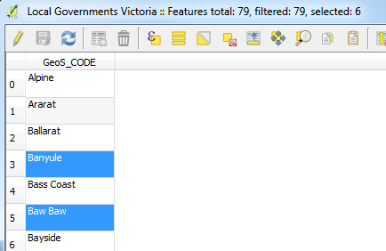
Selection within Attribute Table
Activate layer in the Layer Panel, click on Attribute Table button , then manually select records or use selection buttons to select by expression (see above), invert selection etc. The map will show the selected areas.

Selecting or Filtering Data in Form View
Toggle Attribute Table to Form View (at lower right)
Click filter 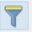 icon
Type criteria into relevant fields, as the basis for seleting or filtering records
(For more, see section ‘Attribute Tables’)

2. Expressions for selecting / labelling: select subset of a field without changing it.
Calculations, used to create new fields in the Attribute Table, actually do something to the field
Select by Expression – can be performed from map view or Attribute Table
This allows an expression to be formed using:
Operators: expressions, such as =, >, <, Like, %, And, Or, Not, In, Toreal, Toint, Tostring
Fields and Values: Fields from the layer activated in the Layers Panel
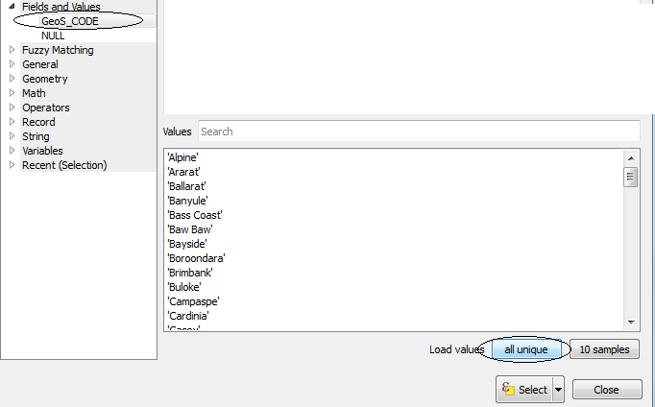
Values of specific features within a particular field in that layer: to obtain the values within a field, open ‘Fields and values’ > select field > click on ‘All unique’ button at lower right. This shows the unique values in that field, and allows you to select one of them for inclusion in your expression

If you cannot find the window for viewing the values in a field, click on the far edge of the window, hold mouse button down and pull to the left to reveal the window
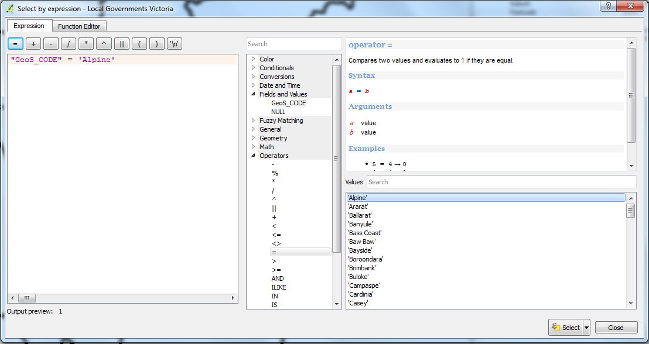

For example, to select the feature ‘Alpine’, from the Local Governments layer, the expression at right specifies that in the field ‘GeoS_CODE’ (which contains LGA names) the value must be ‘Alpine’

‘=’ specifies a precise value, ‘LIKE’ coupled with ‘%’ is less specific, ‘IN’ selects multiple values:
"Municipality" = 'Maribrynong' selects Maribyrnong
“Municipality” != ‘Moreland’ selects everything except Moreland
"Municipality" like '%ong' selects G. Dandenong, Geelong, Maribyrnong
"Municipality" like '%and%' selects Moreland and G Dandenong
“Municipality” IN ('Alpine', 'Cardinia', 'Casey') - does not work with % operator though
Field names are case sensitive, so type names or fragments of names into expressions carefully
‘OR’ ‘AND’ adds statements together
"Municipality" = 'Alpine' OR "Municipality" LIKE '%ong' ‘Alpine, Geelong, Maribyrnong…etc
"Municipality" = 'Alpine' AND “School_Name” LIKE '%Secondary'
‘NOT’ reverses the effect of ‘LIKE’, ‘IN’ – but not ‘=’
"Municipality" NOT LIKE '%ong' all municipalities except Geelong, Dandenong etc
"Municipality" NOT IN ('Alpine', 'Cardinia') all municipalities except Alpine and Cardinia
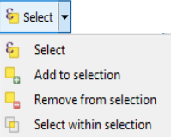
Click ‘Select’ at lower right-hand margin of window and choose from options – including adding to or selecting within an existing selection.

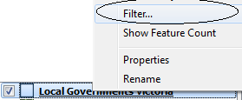
Filter – similar to selecting by expression, except that you have retained all records in your layer, but only filtered them to show a selection.
Right-click layer in Layer Panel > Filter
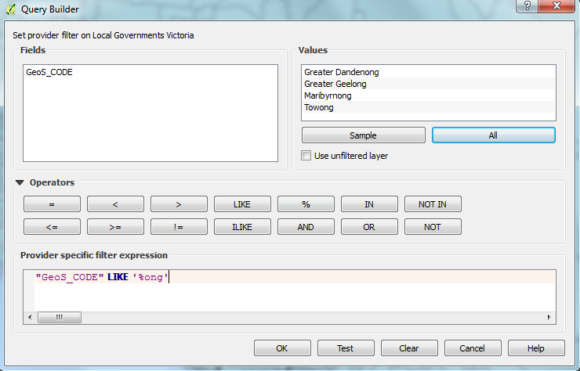

In window which appears, double click on the field required for the expression, then add operators using rules outlined above.

If you select ‘All’ beneath the upper-right window, it will show all the values in the field, for you to select from. Double-click on one to add to expression

Click ‘Test’ to see if your expression works
OK.

As with selections, you can ‘Save As’ and create a new layer based on the features you have filtered for.
The filtered features will show up in the Attribute Table as well – but they cannot be edited.
Once finished: Select layer in Layers Panel > Filter > Filter window appears >
3. Boundaries
Boundary Select
Selecting items (within ‘lower’ layer) encompassed by, or overlapping, the selected boundary of another layer (the ‘upper’ layer).

Eg: Suburbs within Greater Dandenong – selected from a Local Government layer
Activate the upper layer (Local Government, in this case) – which you want to use to select items from ‘lower’ layer (suburbs in this instance) that fall within one of its polygons
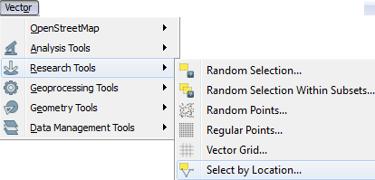
Select a single local government – eg: ‘Greater Dandenong’ –the boundary we will select within

Vector > Research tools > Select by location

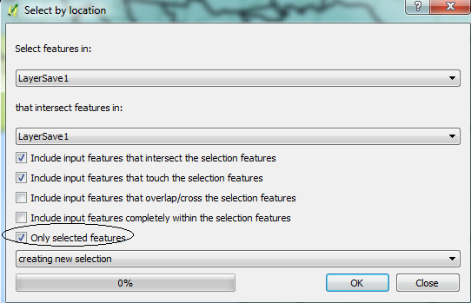

In dialogue box , under ‘Select features in’ choose the ‘lower’ layer – the suburbs layer – as it is suburbs that you want to select

Under ‘That intersect features in’, select the ‘upper’ layer – that the suburbs would fall within – in this case, local government layer

Check boxes below to describe the overlap you want e.g.: touching, within feature etc.
You can also use this selection as a new selection or add/remove from an existing selection
Check ‘Only selected features’ to ensure that selection only occurs within the selected part of the ‘upper’layer

OK then Close

Selections show up in Attribute Table
Incidentally, you can click on ‘Open Attribute Table’ to view the attributes
- the selected features (rows) will be shaded

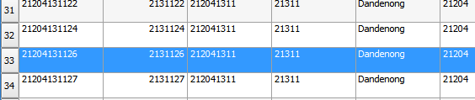

Save Selection as a New Layer
To save the selected suburbs as a layer: Activate suburbs layer in Layers Panel > right click > Save as > in dialogue box check ‘save only selected features’ and give the new layer a name and location.

Unselect
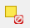 Unselects all selected objects on the map

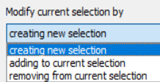
CLIPPING A LAYER (to limit its extent to that of another layer)
Similar to boundary select > save selection
Eg: to clip a Suburbs layer to include only those which fall within Brimbank
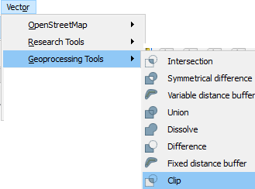
Install both layers in the Layers Frame

Select part of the clip layer (Local Governments, here) to form the boundary of the clip

Vector > Geoprocessing Tools > Clip

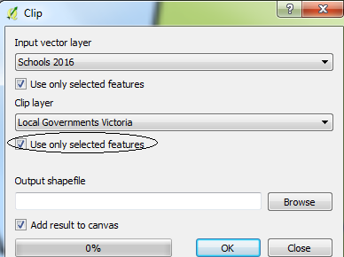
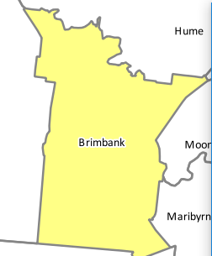
Select:
‘Input vector layer’ – the one being clipped
‘Clip layer’ – the one to whose extent the input layer is clipped
Check ‘Use only selected features’ from the clip layer
Select location & name of the resulting layer

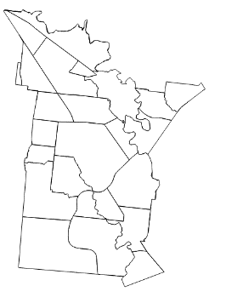
The result is a selection of suburbs from the Suburbs Layer, that matches the extent of a single municipality in a layer ‘Local Governments’
If you clip a layer – such as SA1 areas – you can then map characteristics of that part of the layer which has been clipped, such as SA1 ares within a municipality

Clipping to remove that part of an area which is encompassed by another layer
Eg: to clip a Suburbs layer to remove suburbs which fall within Brimbank
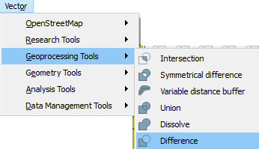
Vector > Geoprocessing Tools > Difference

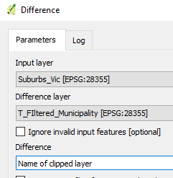

Select ‘Input layer’ – to be clipped, and ‘Difference layer’ whose extent will determine which features of the input layer are to be removed
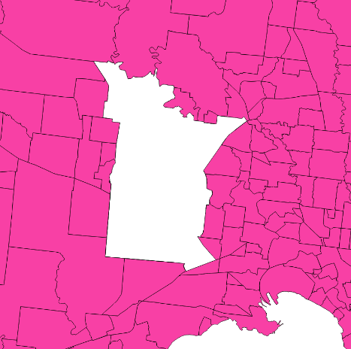

The resulting ‘difference’ layer, shows a gap where suburbs that fell within the area of a single municipality, have been removed

So you can select features of a map to create another by:
- Selecting > Save as
- Filtering on the Map Canvas >Save as
- Clipping
- Select > Control_C > Paste into an editable Shapefile layer of compatible type (points/polygons) – this does not retain the attributes of the file being copied though

LAYER CONTROL
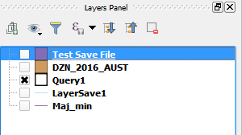
Layers Panel
Situated at lower left of screen
To close, click cross at upper right-hand side of the Panel

If you add a layer (Layer > Add Layer > Add Vector Layer) it will appear in the Layers Panel
- Select and drag a layer to raise or lower it.
- Click on box next to layer to hide or show a layer on the map
- Double-click on the layer name to bring up the Layer Properties window to change its appearance

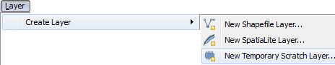
Create a Layer

Scratch Layer – for drawing only, and with no Attributes, but can be saved
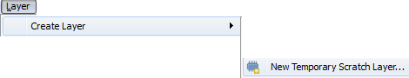
(whereas a new Shapefile layer has to be saved)

New Shapefile layers – include dots, lines and polygons (see later section)

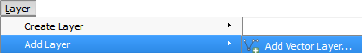
Add Layer
Layer > Add layer > Vector Layer

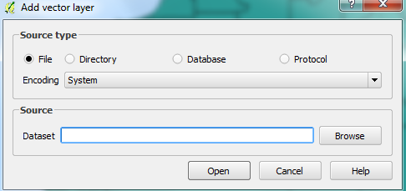

Then select the layer required from your files.
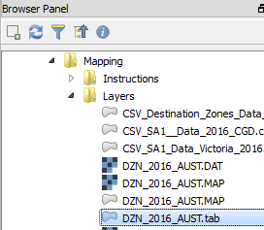

OR/
Double-click on a file in the Browser Panel

To open an old Mapinfo table, select the version called ‘MapInfo Table’ with suffix ‘.tab’
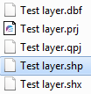

To open a file created by CGIS, select the one with the suffix ‘.shp’

Aerial Layer
Located at T:/GIS/Photo/Photo Dec 2017/Mosaic/greater-dandenong_2017dec11-air_vis_10cm_mga55.ecw
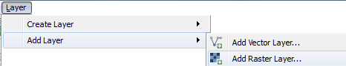
To open: Layers > Add Vector Layer > Add Rasta Layer

Duplicate Layer
Select layer in Layer Panel > Layer > Duplicate layer

Remove Layer
Layer > Remove Layer
Save a Layer
Select layer in Layers Panel
Layer > Save as > then give a name (no spaces) and select a location for the new file
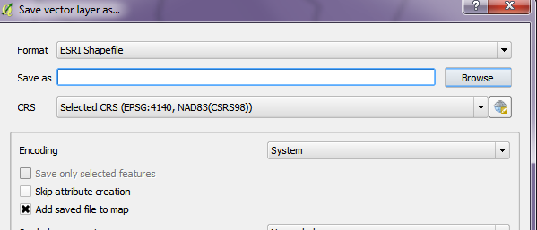
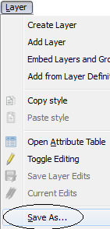

You may also decide whether or not to add the saved file to the map
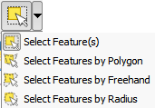

Creating and Saving a Subset of a Layer
Activate the layer in Layers Panel, then select a part of the layer
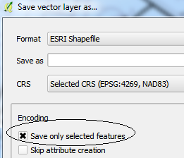
Layer > Save As.

Tick ‘Save only selected features’

Type name and select location for the new layer file

You may also tick ‘Add saved file to map’ to add the new layer to
your map layers in the Layers Panel.

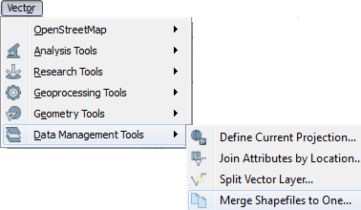

Merging Layers
Vector > Data Management Tools > Merge Shapefiles to One
The layers must have same geometry type: point, line or polygon

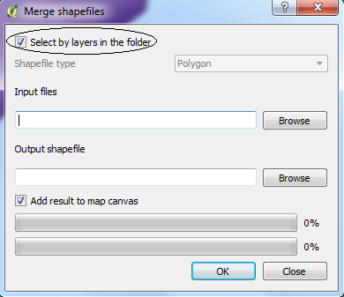

Check ‘Select by layers in the folder’ (Layer panel)
Select layers to merge (input files) as well as a
name and location for the new, merged, file
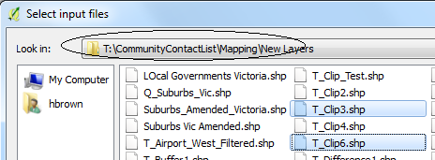

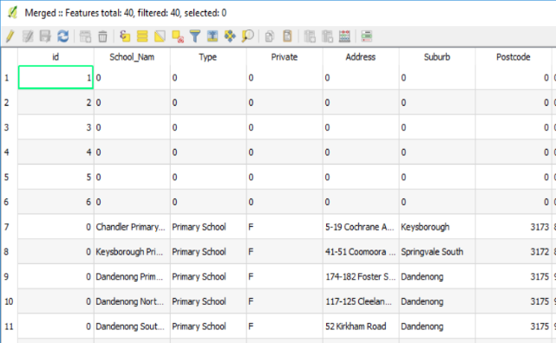

The resulting file now contains fields and values from the two separate files, as the Attribute Table at right illustrates
In this instance, the field ‘id’ from a group of dots is combined with attributes from a file of local schools.

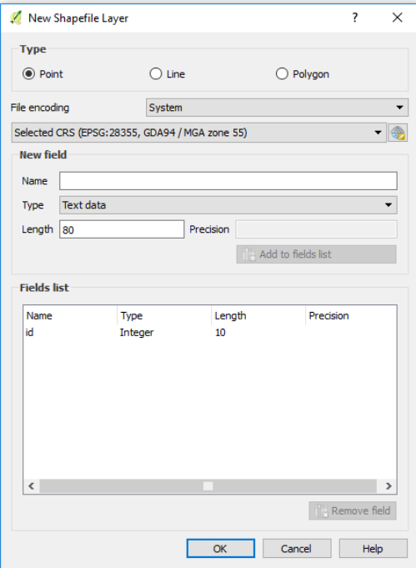
CREATING A LAYER OF POINTS

Layer > Create Layer > New Shapefile Layer

In window, select ‘Point’

In ‘Fields List’, a single attribute (or field) called ‘id” appears
You may add or remove fields, giving each a name, length and type (below)
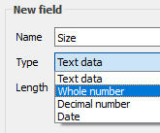

You may remove any field too, including the default ‘id’field created by the computer

OK > select name and file location for this new layer - which we will call the ‘dot layer’
The ‘dot layer’ will appear in the Layers Frame
Open another layer to serve as a point of reference for placing the dots in the ‘dot layer’
Activate the ‘dot layer’ > click ‘Edit’ button 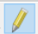 > Click ‘Add feature’ 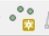

Click mouse in location where you wish to place a dot

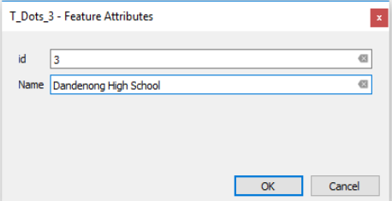
In window which appears, type information into the fields you added when you created the ‘dot layer’

When you’re finished, change appearance in Layer Properties window, if necessary.

When done, Layer > Save as, or untick edit button , and you will be prompted to save

Adding further Dots Later
At any time, you can open the layer, then:
- Click ‘Edit’ , click add new features along with the attributes of each.
- Open the Attribute Table for this layer, make it editable and add or amend its attributes

Editing Attributes of each Dot
Activate dot layer in Layers Panel > Open Attribute Table >make editable > amend data in shaded row (representing a selected dot) or in other rows

CREATING A LAYER OF POLYGONS, CIRCLES OR LINES
Eg: for highlighting a study area or area within a certain radius

Creating Layer
Layer > Create layer > New Shapefile layer
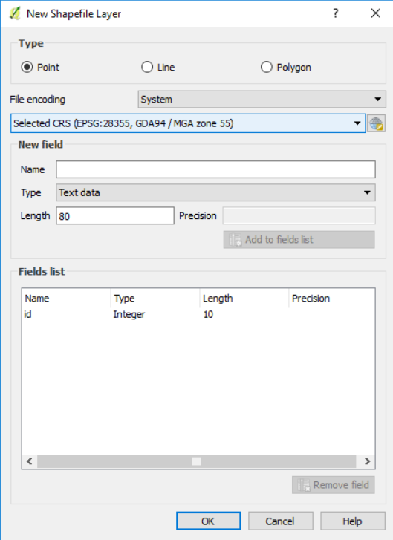
Select ‘Polygon’ or ‘Line’

Give this new ‘polygon layer’ a name and location

In window, add new attributes, or remove default ‘id’, if required – as per previous page > OK

Drawing Your Shapes
Click edit button to start adding circles, lines, polygons

Polygon or Line: Click Add Feature button 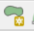and draw a polygon onto the map layer, then right-click to finish
Move the drawing: Click ‘Move feature’ button 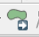, select feature and move it
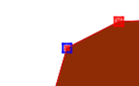
Adjust drawing: Select ‘Check Node Tool’, 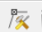 > select node (it’ll turn blue) :
- Then hold left mouse down and drag the node to a new position or/
- Click ‘Delete’ to remove

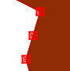
Add new node: double-click on perimeter of the polygon or line to create a new node

Changing Appearance of Dots, Lines or Polygons
Activate and double-click layer in Layers Frame > change colour, outline etc. in Layer Properties window

Deleting Dots, Lines or Polygons
Make layer editable > Select object > Delete

Copying and Pasting Dots, Lines or Polygons into a New Layer
Select some dots/polygons from current active layer > Control_C
Now, to paste the items: In existing layer: make editable > Control_V
Into new layer: Edit > Paste features as > New vector layer

CREATING BUFFER LAYERS FOR POINTS OR POLYGONS
Activate layer to be buffered
Select polygon/s or dot/s to be buffered – unless you want the buffer may be added to all of them

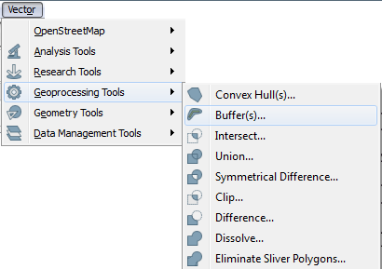

Vector > Geoprocessing Tools > Buffer

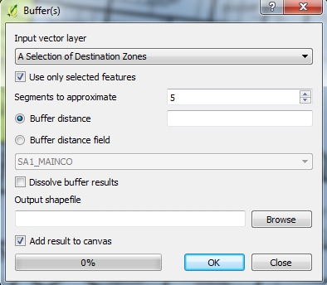

Select layer for buffer
Note ‘Use only selected features’ is ticked

Add buffer distance (which is in meters)

Click ‘Browse’ to give a name and location to this new layer

With this buffer superimposed, objects in a layer within the buffer area could later be selected, and characterised as features (towns, houses etc) that lie within x meters (whatever the buffer radius was) of the area that was buffered.

Drawing a Circular Buffer – as a substitute for a circle of exact radius around a point of interest

Layer > Create Layer > New shapefile layer > check ‘Points’ as type > Save
Place a point on this new layer, with a map visible beneath, to guide its placement
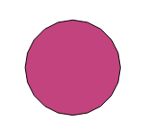
Activate the new layer in the Layers Frame, select the point, then create a buffer around the point, giving the buffer distance as the radius of the area you wish to highlight.

Once the new buffer layer is done and saved, change its appearance to remove fill from the buffered area

Open the buffer layer above the map layer where you wanted to highlight an area around the point of interest.

LAYER PROPERTIES

Double-click on layer in the Layers Panel or/ select layer > R-click > Properties
A dialogue window appears, allowing you to:

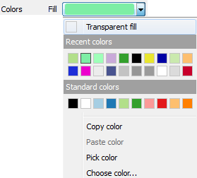
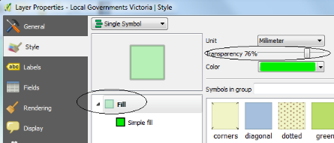

Set fill, border and point style Change
transparency
of fill

Area includes fill, fill style (solid, brush – nothing, patterns), border style, width and colour
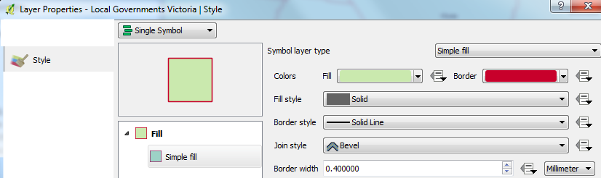
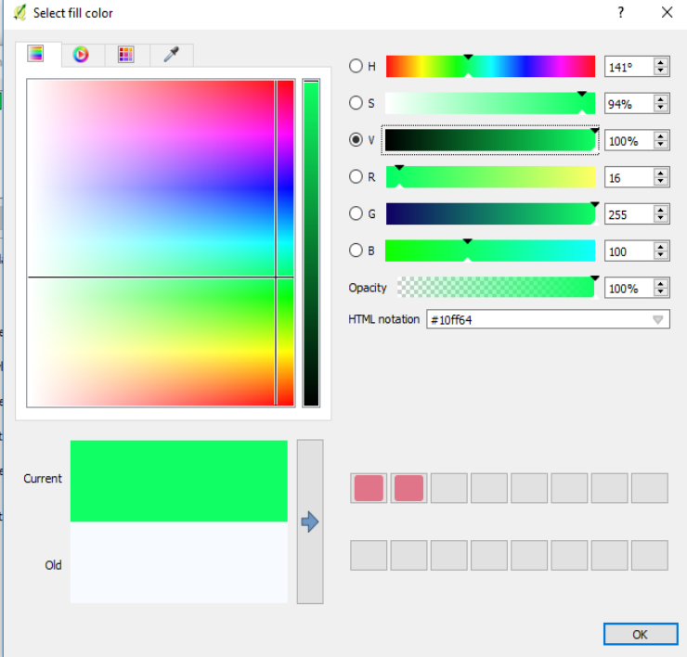
For transparent layer: Colours > transparent fill or/ Fill Style > no brush

For adjustment of colour of fill or outline

Slider ‘V’ – brightness/darkness
Vertical bar – colour saturation
Horizontal bar – colour selection

Points – include colour, outline colour, style, width, shape (scroll down to view selection of shapes)
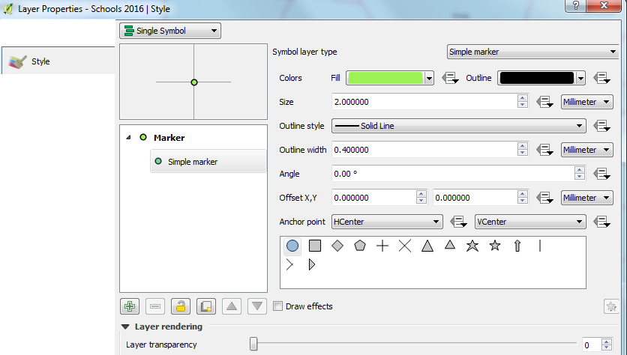

Adjust transparency of whole layer
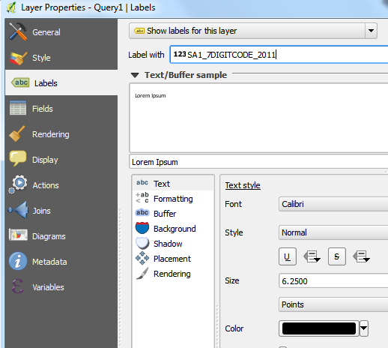
Set label style – including:

Text tab:
Whether to show labels for the layer,

Label with: What field to use for the labels

Text Style: font, style, size, colour, transparency

Buffer tab:
Addition of a buffer area highlights text against dark backgrounds . Size 0.5 is satisfactory.
Placement tab:
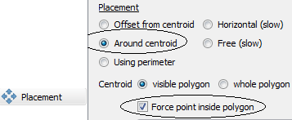
For polygons: Placement tab > ‘Around centroid’/‘Offset from centroid‘
Force point inside polygon - to set labels neatly near the centre of polygons.

For points: Choose from ‘Offset from point’ & ‘Around point’
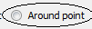

Labelling Selected Features by Expression
Select features of layer > Save as > check ‘Save only selected features’ > Add labels to this new layer
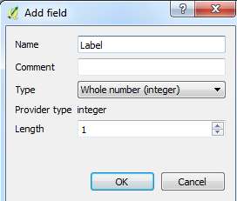
Place this new, labelled layer, above the layer from which it was derived OR/
Activate map layer > Open Attribute Table > make editable > create new field
Name new field as ‘Label’ and set as ‘Whole number (integer)’
Assign the value ‘1’ to features that you wish to label

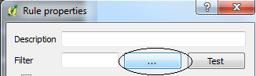
In Layer Properties window, ‘Label’ tab:
- Select ‘Rule-based labelling’
- Click on the symbol at lower window
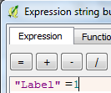
- In window which appears, click button, next to ‘Filter’

- In expression builder window, create expression “Label” = 1
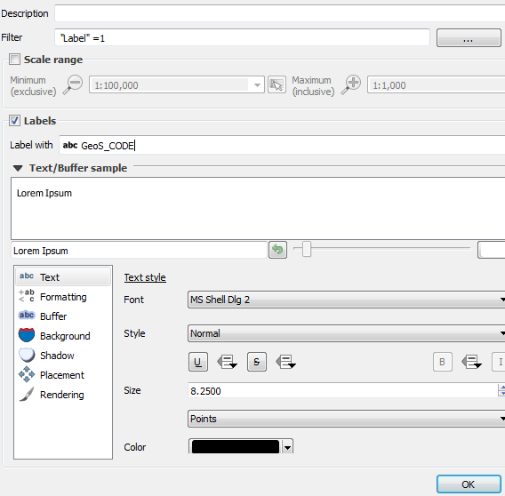

Select field labelling and other characteristics of the labels, as above > OK

Return to Layer Properties window > Apply > OK

Select ‘Rule-based labelling’ > Create expression such as: “Municipality” In (‘Ararat’, ‘Buloke’, ‘Casey’ etc)
Choose field for labels & label characteristics
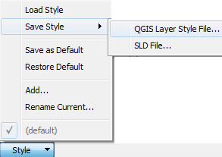
Saving and Applying Styles

Save a Style
Style > Save Style > QGIS Layer Style File > set its name & location

Apply a Style
Style > Load Style > Locate style file of type ‘QGIS Layer Settings’ in folder where it was stored > Double-click on the file – you will be returned to ‘Properties window’ > Apply > OK
But, loaded style must be of the same geometry type (dots/polygons) as the shapefile you are formatting.
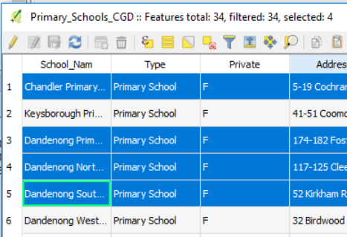
ATTRIBUTE TABLES (browsers)

Opening an Attribute Table
Or/ Click on 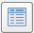 at top of screen

Selecting Rows (or features) from the Table
Click on far left of the table, to select a row
Hold own Control to select unconnected rows
Hold down Shift to select a continuous group of rows

Selecting Using Buttons
- Select all fields Invert selection Moves selected rows to the top of the table
- Deselect all Selection of rows by creating an expression

When you select a row in the Attribute Table, the corresponding feature on the map is selected. Inversely, if you select item/s in a map, the corresponding row of the Attribute Table is highlighted.

Just as you can select features of a map, then save them as another map layer, you can select rows of a map layer in its Attribute Table, then save them as another map layer.

Editing Data in Form View
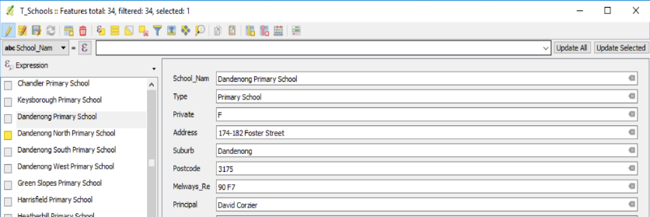
In Attribute Table > make editable > toggle buttons in lower right corner > then toggle filter button to reach Form View edit (vs. Form View filter)
Select a feature at left, then complete or edit its fields in the form at right.

Filtering/Selecting Data in Form View
Toggle Attribute Table to Form View (at lower right)
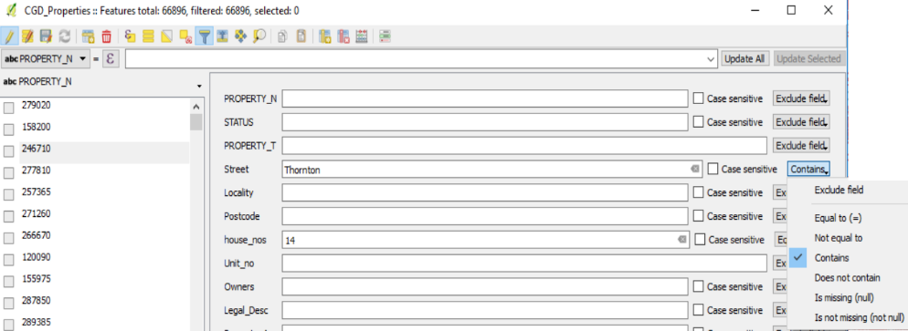
Toggle filter icon to reach Form View filter/select (vs. Form View edit, above)
Type criteria into relevant fields, as the basis for filtering/selecting records

Each row adds a criterion to the selection, like ‘AND’ in an expression.

At right of each field, choose whether to filter for values in that field which are equal, not equal, contain or do not contain that value. For real & integer variables, =, >, <, ‘between’ are offered as options.
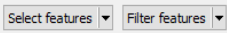
At lower right of window, choose to select or filter for these attributes
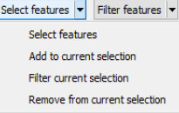

Or/ To filter for selected features, chose at lower left of window.

To view selected features on map, goto Map Canvas > click button to centre map on the selection
Creating a Dot Layer to Depict a Selection of Addresses
Three steps: Select a single address with Attribute Table Form View filter or Select by expression
‘Zoom to selected features’ , in Map Canvas
Attach dot to the selected location

Activate PropertyNo Layer > open Attribute Table > make table editable

Put Attribute Table in Form View filter – as described above

Type in street name and number in relevant fields [try to be precise, even with streets, so that you can select the option ‘equals’, rather than ‘Contains’ – which often selects a number of features (rows), making it hard for the computer to zoom in on a specific feature]

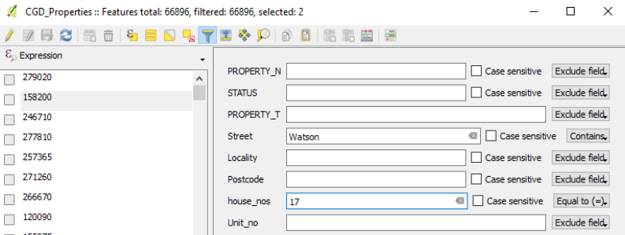
Click at lower right edge of window

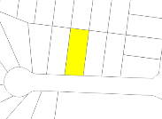
Minimise Attribute Table
Return to Map Canvas > click ‘Zoom to selected features’ button to view selected feature
Make sure property layer is active

Activate dot layer > place dot on selected property > type attributes into fields
When finished, click ‘Unselect all’ button and re-activate property layer, to repeat the process.

In Map Canvas, Activate PropertyNo Layer > click ‘Select by expression’ button
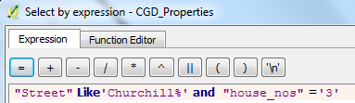

Type in an expression which selects the street name and street number. Street names etc. are case-sensitive in Expression builder

Sometimes an expression such as:
"Street" like 'Wattle%' and "house_nos" like '2%' and "Unit_no" like '7%'
Works better than an expression which is more specific, such as:
"Street" like 'Wattle%' and "house_nos" = 2 and "Unit_no" =7

Then click ‘button at lower right of Expression Builder window (Don’t close Expression Buider)
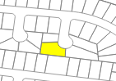
Click ‘Zoom to selected features’ button

Activate your editable dot layer and place dot on the highlighted yellow property.
When finished, click ‘Unselect all’ ,, activate property layer and return to Expression Builder, to repeat the process.
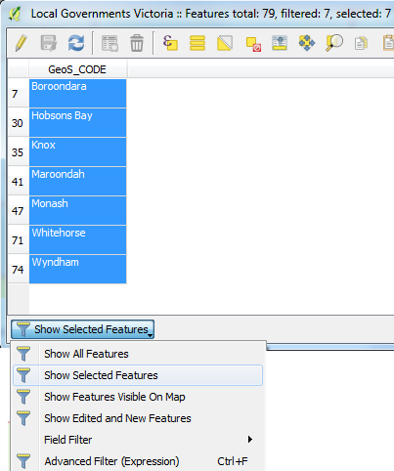
Filtering Data in an Attribute Table
[Doesn’t affect map. It’s only about viewing data in the table]
At lower left-hand edge of the Attribute Table is a filter icon

Clicking on the filter icon allows you to choose whether to view all rows or ‘features’ in a layer, just selected or visible rows, or use an expression to select rows.
The filtered rows can be copied and pasted into Excel
Closing the Attribute Table restores the full list.

Sorting data in an Attribute Table
Open the Attribute Table
Click on the field you need to sort by and the data rows will be sorted in ascending or descending order of that variable

Editing an Attribute Table – beware: changes you make here are permanent
Select a layer in Layers Panel > open Attribute Table
Click on the pencil icon at left to make the table editable – as with making maps editable
Alter the data: double-click on a cell to edit its contents
Add a field: Click on the 'Add new field' icon at far right to add a new field. Name it, select its data type & add data – one row at a time
Calculate a new field: Unlike expressions, these actually do something to a field
Click on the ‘Calculate field’ button then….
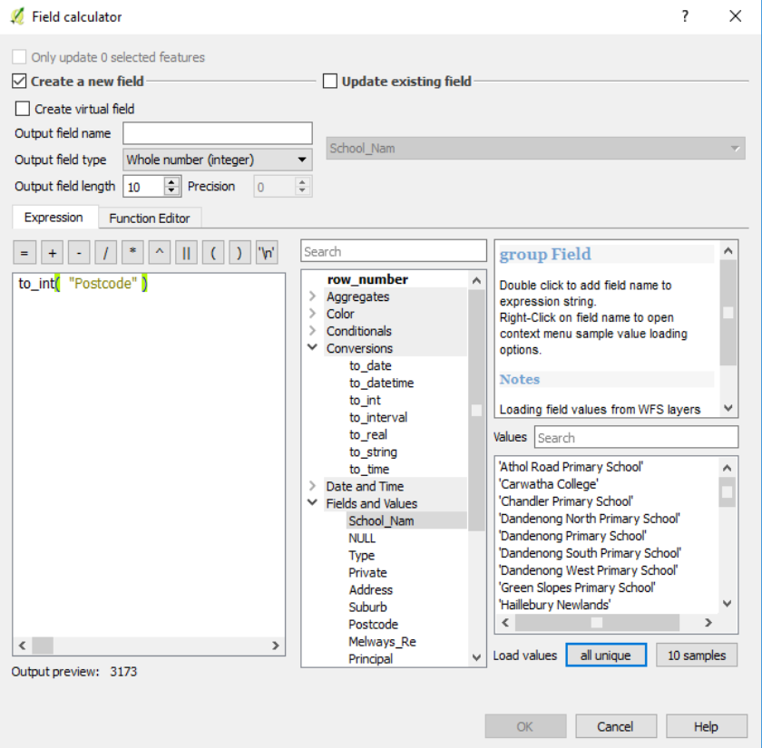
* Name the field and create an expression based on values of the fields and operators
Eg: to_real(“Field”), “Field” * 100 etc
* Select ‘Output field type: whole number, decimal number, text etc.)
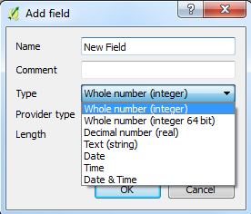

* Select ‘Output field length’ and ‘Precision’ – number of digits after the decimal point
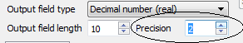

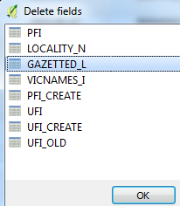
For more complicated expressions:
CASE
WHEN "cat" > 100 THEN 2
WHEN "cat" > 10 THEN 1
ELSE 0
END
Delete a field: click then select field
Or replace numbers with words, eg: ‘High’, ‘Low’
Fields have quotation marks “, & categories a single ‘
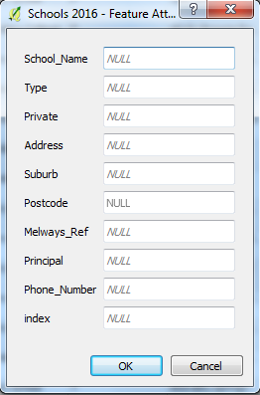
Add a row of data (a feature): click ‘add feature’ icon & fill in values for each field of the new row
(illustration, left)

Delete a row of data: select row at left, then click on ‘delete feature’ icon

When finished, click on pencil to conclude editing, then indicate whether to save or discard changes.
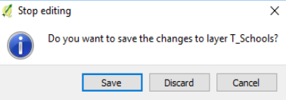

Pasting Data from an Attribute Table into Excel
Activate a layer in the Layers Panel > open Attribute Table > select rows > Control_C > paste into Excel
Or/ Select part of a layer in Map Canvas or Att Table > filter for selected features > copy > paste into Excel
Pasting Selected SA1 Areas into Excel – for a profile
Select SA1 areas on the Map Canvas > in Attribute Table, filter for selected features (rows) > copy > paste into Excel and select values in the 7-digit SA1 column

JOINING EXCEL DATA TO A MAP LAYER – to make it mappable

Save the Excel data file as a CSV file (Excel file should have field names <10 characters)

Assign Properties to Fields your CSV File – to ensure it can be mapped
Open notepad, and specify the field types in the CSV file, in one line, each in quotation marks and separated by commas e.g.: For a CSVT notepad file to accompany a CSV file with fields: 7-digit code, Population, Per cent Vietnamese -“String”, "Integer", "Real”
You can specify width & precision of each column e.g.: "Integer(6)","Real(5.5)","String(22)"

Save this with same name as the CSV file, and in the same folder, but with the suffix .CSVT
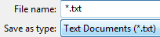
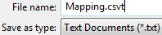
ie: Change file name suffix from .txt to .csvt

When you merge the CSV file with a map file, in QGIS, the field characteristics of the data from the CSV file will be as you specified in this CSVT file, enabling fields with numbers to be treated as numbers.
To retain these instructions about file type, CSV file must be imported into QGIS via: Layers > Add layer >Add Delimited Text file layer

Import the CSV File into QGIS (the CSVT file, with its instructions, will come too)
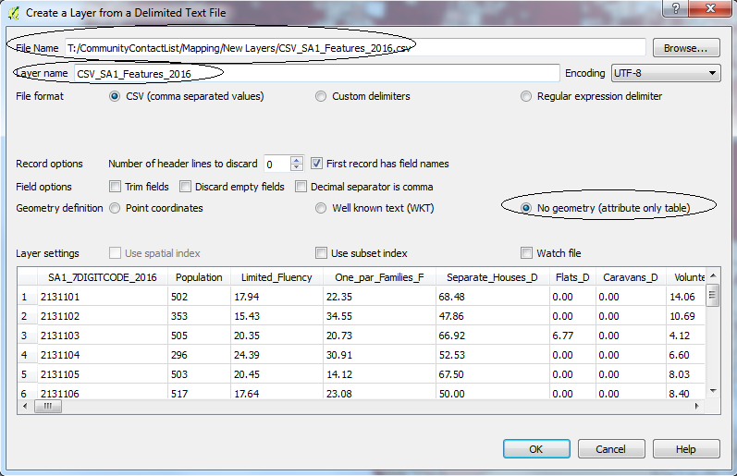
Layers >Add layer > Add delimited text layer
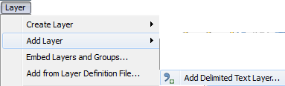

In the window which opens, browse to select the CSV data file
Change layer name if you wish

For ‘File format’, check ‘CSV’ (default)

For Geometry Definition, select ‘No geometry (attribute only file)’

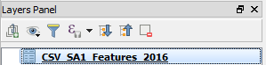
The file will now appear in the Layers Panel, with an icon

Double-click on the map layer you wish to connect the data table to.
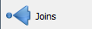
In the Layer Properties window, select ‘Joins’

If a layer appears at the top of the window, select it and click to remove it (You can’t join fields from a CSV layer which already has fields joined to the map layer)

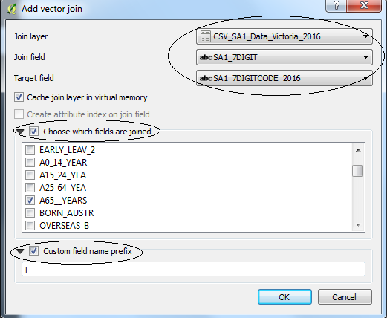
Click on the button at the lower left-hand side of the window
In the window, select the:
- Join layer (the data table you have saved as CSV and opened as a ‘No geometry’ file)
- Join field (the field in the join (CSV) layer that you want to link to the map layer)
- Target field (the field in the selected map layer to be matched to the join field in the CSV file)
Target & join fields should be the same case – eg for suburbs
- Choose which fields from the join layer (CSV) will be joined to the target field (a map layer) - optional
- Choose a customised field name prefix (this will be appended to the original CSV field names in your map file –
Keep it short or blank, otherwise the full name of file will be used)
Converting Values in the Combined Map and CSV Layer to Numbers – for mapping attributes (If the step above has not been taken)
When a CSV file is connected to a map layer, its values in some fields may not be recognised as numbers and may therefore be impossible to map as ‘Graduated’ data – that is, as ranges of values, each assigned a different colour

Activate layer in Layers Panel > Open Attribute Table > click to make editable

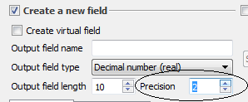
Click ‘Calculate attribute field’ button

Type new field name

Select field type - ‘Whole number’ or ‘Decimal number
For decimals, under ‘Precision’ sets the required number of values after the decimal point

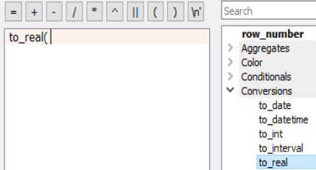
Under ‘Conversions’ select the operation ‘to_real’ or ‘to_int’

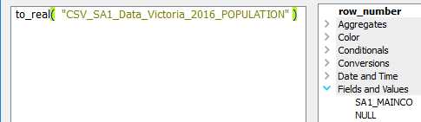

Under ‘Fields and Values’ select the field to be converted to numbers > OK
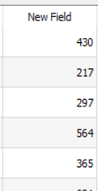

…and now the new field will appear in the Attribute Table.

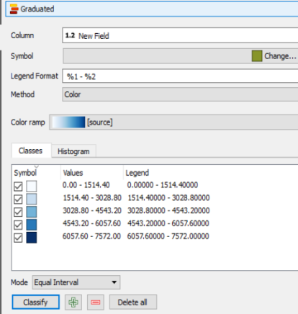

This new field may now be mapped as a ‘Graduated’ field’.

Joined Fields are Temporary, Unless the Map Layer is Saved under another Name
To preserve the map layer with joined fields added to it: Layer > Save as
Otherwise, layers added through joining fields are temporary and will disappear when you either:
- Close the CSV layer which provided the fields
- Remove the join, shown here in the Join Field window, by selecting it and clicking the delete button

IMPORTING TABLE OF DATA WITH LAT & LONG CO-ORDINATES

Open QGIS
Click on comma symbol (create layer from comma-delimited text file)
Or/
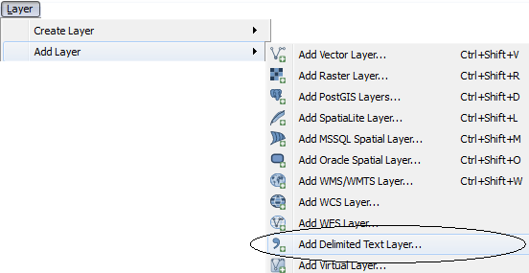

Browse to locate required CSV file

In dialogue box which opens:

- File format: click ‘CSV
- For x field: choose ‘Long’
- For y field: choose ‘Lat’
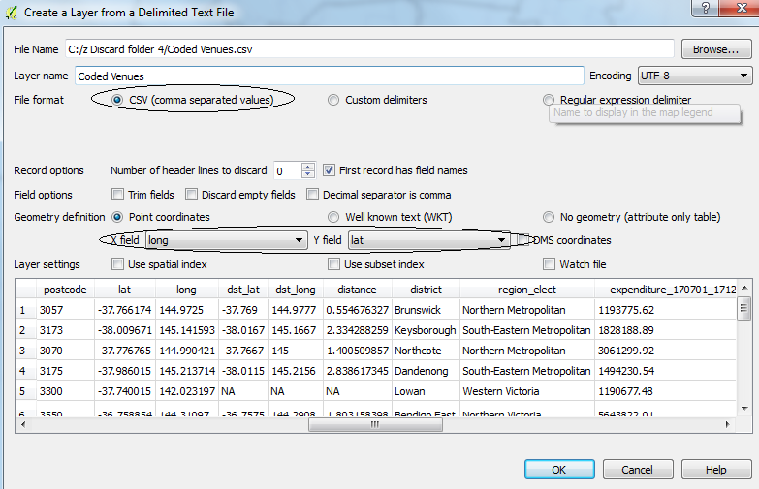

OK

MAPPING ATTRIBUTE FIELDS

Mapping Points – that is, giving them colours, based upon their values
Double-click on the layer > click on ‘Style’ tab in the ‘Layer Properties’ window
Then select:
*‘Categorized’ (If you want dots coloured differently for each nominal category)
*‘Graduated’ (If you want dots coloured by numerical ranges)
Click ‘Column’ to select the field which forms the basis for colouring the dots
In ‘Colour Ramp’ select a colour scheme, if you wish

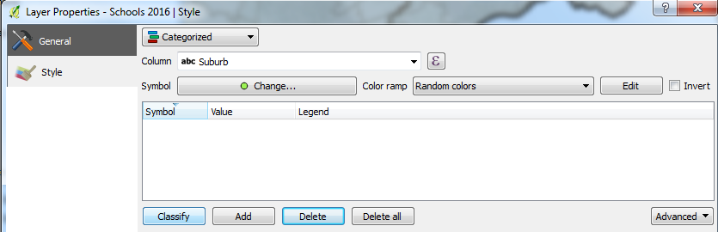

If ‘Categorised’: just click the ‘Classify’ button at the lower part of the window
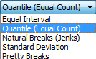
If ‘Graduated’: first select whether ‘Quintile’, ‘Equal interval’,’ Natural break’

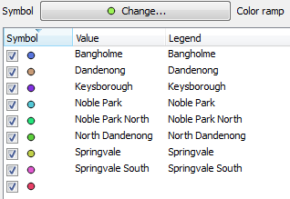

The dot colours and values within your chosen field that each represents, will appear in the window

To hide particular categories in the map, uncheck the box at left or delete: click or

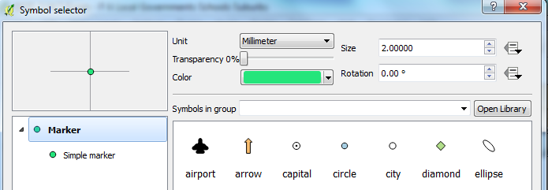
To change appearance of a single dot, double click on it in the Layer Properties panel and make adjustments in the window (right)

To change appearance of all dots, click to adjust their shape/size/outline
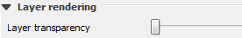
Set layer transparency level, at lower part of screen

Once complete, click ‘Apply’ and ‘OK’
Save the map, if required

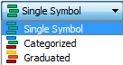
To revert to a single symbol for dots on the layer: Double-click layer in Layers Panel > select ‘Single symbol’

Mapping Shapes - as for instance, SA1 areas by characteristics of its population
Once file is ready, save it first, as you cannot ‘Save as’ after you have prepared a map

Double-click layer in Layer Frame > select ‘Style’ tab in Layer Properties window

Select ‘Graduated’ at top of window

Column: select the field whose values you wish to map

Symbol: Click & ensure that ‘Simple fill’ fill style ‘Solid’ (and not ‘no brush’)

Colour ramp: select the palette
(Use ramps of similar colours: Blues, Greens, Greys, OrRd, Purples, Reds, YlGn, YlGnBu)

Number of classes: select number of categories for your data to be grouped by
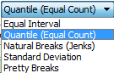

Mode: select method for grouping data: Equal interval, Quantile or
‘Natural breaks’ (where zeros account for more than a fifth of the values - otherwise 2-3 quintiles may be zeros), then click ‘Classify’

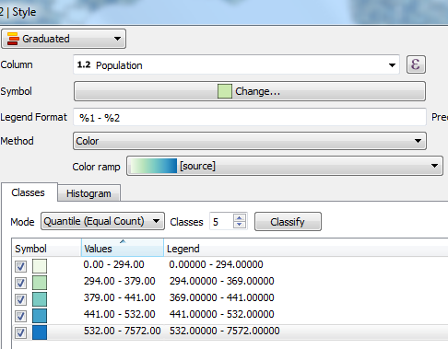
The symbols (colours) and value ranges will appear in lower window (click ‘Classify, if necessary)

Double click on values if you wish to alter the ranges – which will alter adjacent ranges as the system seeks to include all possible values within the range of the field

Click on ‘Precision’ 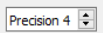next to ‘Legend Format’ to adjust no of decimal places in legend

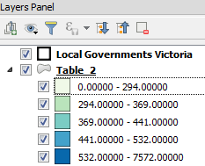
Adjust Layer transparency in lower part of window
Apply > OK

Now the colours for each value range will be shown with that layer in the Layers Panel

To change or replace the map, activate and open the layer and repeat the process described above.

Removing a Map
Select ‘Style’ tab in Layer Properties window > ‘ and choose shape & colour

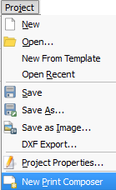
PRINT COMPOSER

New composer: Project > New Print Composer

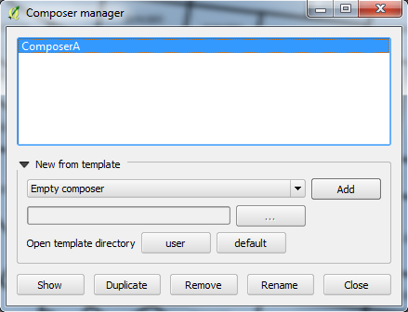

Existing composer: Project > Composer Manager > select composer required from dialogue box > click ‘Show’

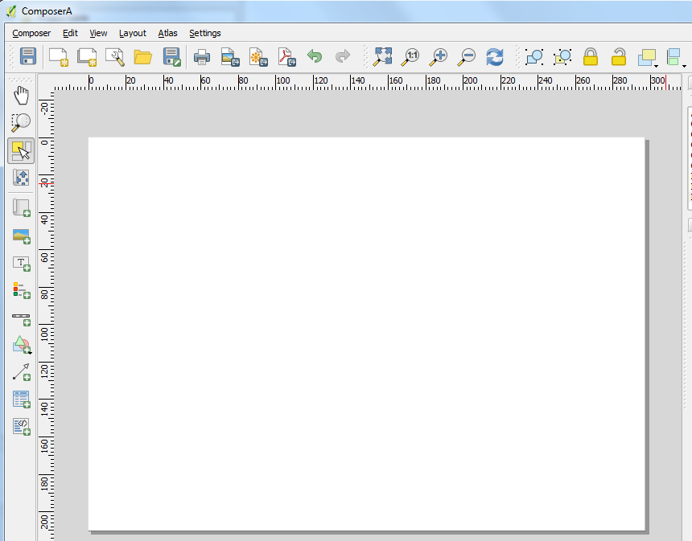

Either way, the Composer window opens:

Resizing Print Composer
Click on magnifier icons 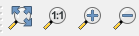 to change size of composition area on the screen.
Click on for a good fit for your map or on at lower edge of screen for a precise adjustment

Adding a Map
To add the map: click on icon then draw a rectangle in the Composer and an image of the current map appears
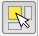
Moving the Map/other Features
To move the map frame or any other map feature, click on .
Then click inside the map, hold the left mouse key down and move it around.
To expand the map, click on edge of the map, hold left key down and drag.

Moving Contents of Map
Click on to move the contents of the map without moving or altering its frame

Adjusting Size of Map
Click ‘Set canvas to map extent’ in Map ‘Item Properties’ window, to adjust map to its size in Canvas
Adjusting Content of the Map – updates Composer to match changes in Map Canvas – not size.
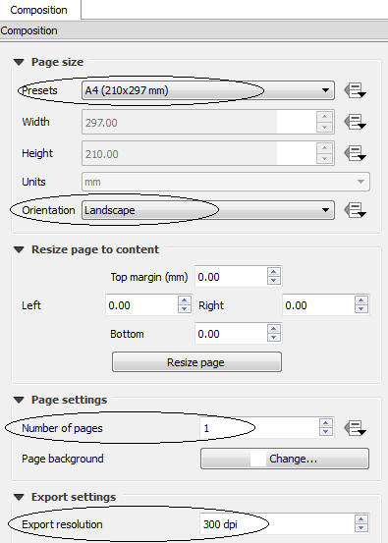
Map window characteristics
Get picture right on Map Canvas first
Composition: this window applies to the overall composition window, and specifies the page size, orientation, number of pages and export resolution (lower image)

For ‘portrait’ layout set the ‘Composition’ window to portrait, create map as usual. The map in Map Canvas will be presented in its full lateral extent in Composer, though its vertical extent in the Composer will be greater than on the Map Canvas

Frames
Selection: Click ‘Select/Move’ 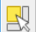button and select frame of any object in the Composition window
Deletion: Click same button, select frame > press ‘Delete
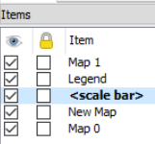
Item Properties Windows: When you select a frame around an object in the Composer, a panel with the tab ‘Item properties’ appears to the right of the screen presenting options for adjusting its appearance and characteristics.
Items Window: Shows the objects in the Composer.
Unchecking item at left hides it
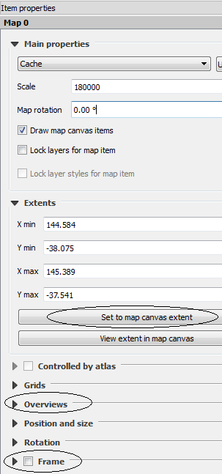

Main Map
For the map itself, ‘Item properties’ window is at left.

‘Set map to canvas extent’ adjusts map to its size and position in the Map Canvas
By contrast, refresh adjusts map to reflect its contents in the Map Canvas – but not size

Overviews: See information about inset maps

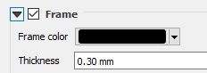
Place a frame around the selected map/object
Adding other items Map

Picture

Text

Click on buttons Legend

on the left-hand side of the screen Scalebar

Text
Click on icon, then use left-hand mouse button to draw a text box on the composer.

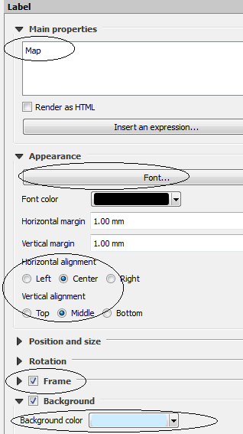
When the text box is selected, its ‘Item properties’ frame appears at right.

Type the text into the area under the heading ‘Main Properties’.

Click on ‘Font’ to adjust the font type, size, colour and alignment.

Adjust horizontal and vertical alignment

Place a frame around the title

Give a background to the title, if required

Scalebar
Click on scalebar icon at left, then draw on screen to get a scalebar.
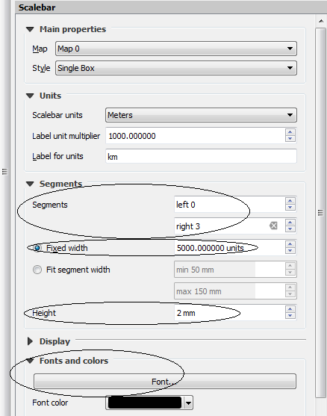
As with selection of box for image, when you select the scalebar, the panel on the left allows you to adjust features such as:

- Choose segments to the left of zero
(usually none) and to the right

- Select number of meters per segment to create a suitable size for the scalebar

- Height (that is, the thickness) of bar

- Font size and colour

Images and North Arrows
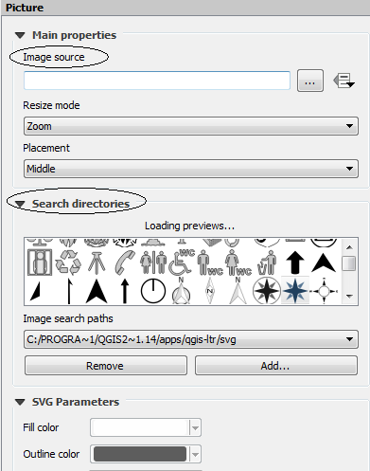
To add an image, click ‘add image’ button at left, then draw a frame on the map for placing the image.
Picture Properties window appears at right, with options for adjusting your image

Click on ‘Search directories’ to locate mapping images, such as a north arrow

Otherwise, click on button next to ‘Image source’ to locate some other image in your directory.

Legend
Click on the legend icon 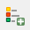 at left, then draw a box in the Composer and a legend will appear.

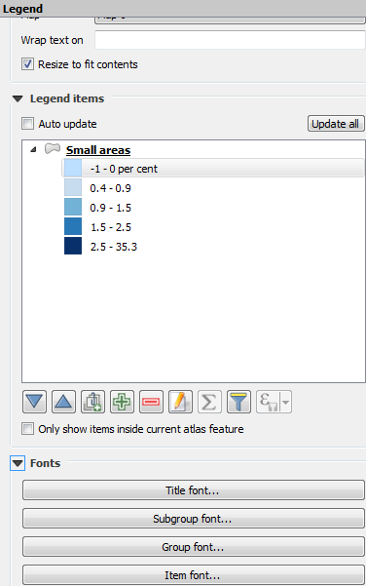
When the legend box is selected, a window will appear at right (as usual) with options for adjusting the legend

To make changes, unclick the ‘Auto update’ button

You can:
‘- add or remove layers or map categories that are visible in Map Canvas

‘- move legend items up/down

- change the title (ie: ‘Legend’) adjust font of title, subgroup (ie: name of variable) or item (ie: usually the numbers)

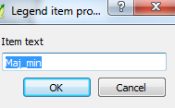
- double-click on any legend item to view a window and change its name

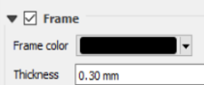
‘- add a frame & perhaps a background

Adjustment of precision of legend ranges in Layer Properties in Map Canvas, will be reflected in Composer

If you click or check ‘Auto update’ at the top of the legend panel, it will obliterate changes made to the legend and revert to its original format and content.

Adjusting Positions and Placement of Map and other Images in Composer
Two or more images – such as the map, scale bar, north arrow or picture – may be grouped, locked, moved in front of, or behind, each other, or aligned.
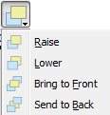
Grouping: select items while holding Shift key, then click on group or ungroup icons 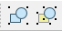
Locking images: select image/s then click 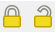buttons

Moving items in front or behind: Select item then click which gives options

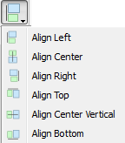
Alignment: Shift-select items and click which gives options

Moving items up, down left, right Select item, hold Control and
tap up and down keys

Adjusting background: for legend, toolbar, title, check ‘Background’ in Item Properties window, and choose a colour, or leave it unchecked for no background
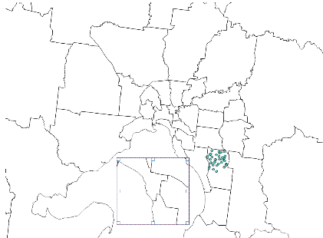
Adding an Inset Map
Creating Inset Map
In Map Canvas, zoom into area that you want as your inset
In Composer, click ‘Add map’ icon and draw frame for the inset map. The inset map will now appear. With the insert map frame still selected, click ‘Set map to canvas extent’ if it helps

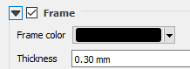
Select inset map (or select ‘Map 1’ in the items list window) then check ‘Frame’ and choose a colour/thickness for a frame around the inset map

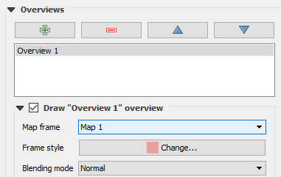
Adding Overview
‘* Select main map (‘Map 0’ in items list window)
‘* In ‘Items properties’ window > Overviews > click green cross.
‘* Then for ‘Map frame’ select ‘Map 1' - This instructs that overview should correspond with the inset map – which is Map 1’
* In ‘Frame style’ click ‘Change’ to alter colour of the overview
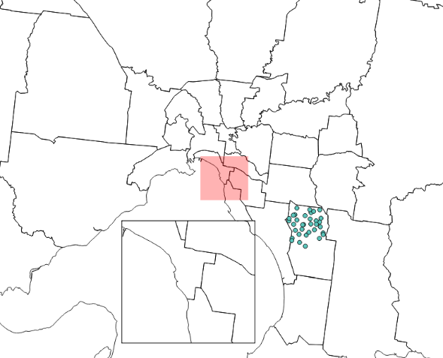

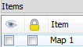
* To remove overview,
uncheck ‘Map1’ in Items window

Exporting the Composer Map
Click on buttons at the top of the screen: 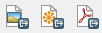 - to export the image within the Composer as ‘Image’ as JPEG (and other image file types), SVG and PDF files, respectively.

Clicking on either of these buttons will first update the map in the Print Composer to reflect any changes in the content of the Map Canvas, then create an image of the resulting Print Composer.
So once you create a map you like, don’t change the Map Canvas!

SETTING PARAMETERS

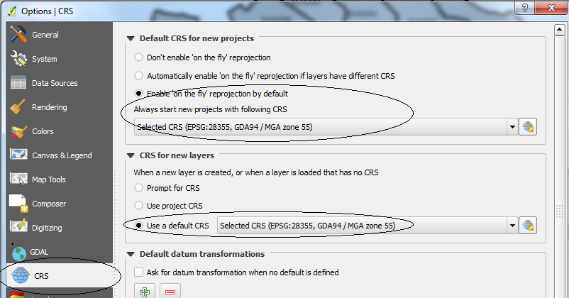
Setting Default Parameters

Projections

Settings > Options > CRS Tab

Check ‘Enable ‘on the fly’ re-projection – it’s usually the default

Select projection types for new projects (above) and for new layers (below)

Set projections at GDA94 / MGA zone 55 as the ‘Default CRS for new projects’ (uppermost, above) and as ‘CRS for new layers’ (below)

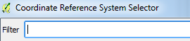
To select from the long list of options, click on the icon to the right, then type in GDA94 in the filter section of the window, to filter for projections with these letters and numbers.

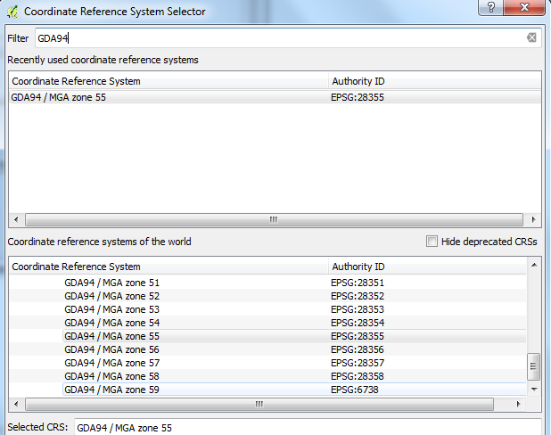

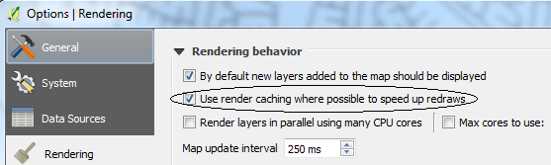
Rendering

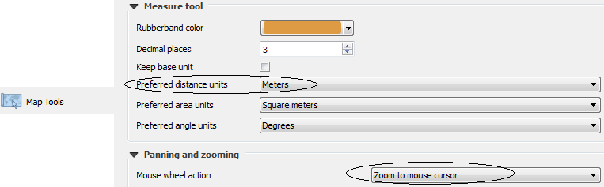
Map Tools

Setting Layer Projection
Double click on layer > in Layer Properties window > General tab > Co-ordinate Reference System
Default CRS (EPSG:28355 – GDA94 / MGA zone 55)
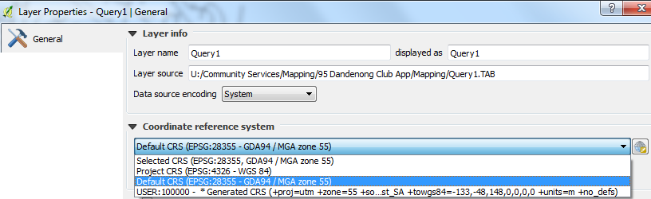

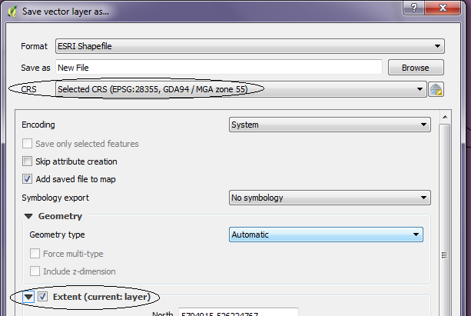

Save As for Layer Projections
In window where you give the name and location of the new file, check its CRS is set at the default and check ‘Extent (current layer)

Setting Project Projection
Project > Project Properties >
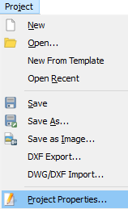

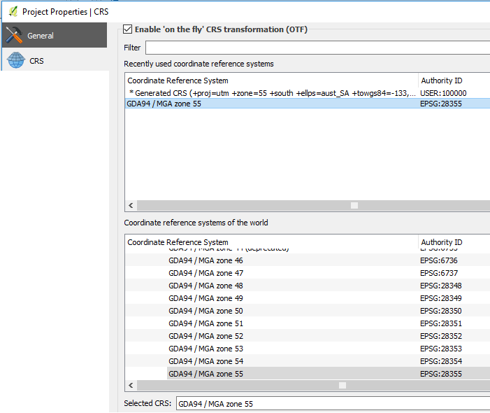

Select ‘CRS’ tab and choose projection

PROJECTS

Creating Projects
Project > New 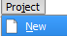 Then open layers etc. to commence the new project

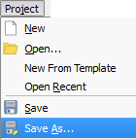
Saving Projects

Project > Save

Project > Save As >

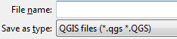
Select location and name for the project
(leave no spaces in project name)

Opening Projects
To open a project: Project > Open > then select the project from the file where it is stored
Only QGIS Project files will appear in your search.

INSTALLING PLUGINS & REMOVING QGIS
Plugins > Manage and Install Plugins 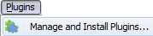
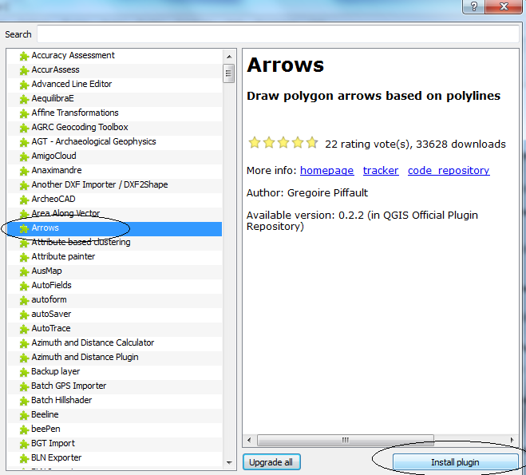
Select from the list of plugins > Install plugin

Useful plugins may include:
- Open layers
- Freehand drawing

Removing QGIS – e.g. from Home
Left-click  icon > type QGIS in box

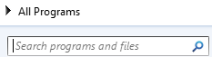
Right-click on QGIS when it appears in the programs list
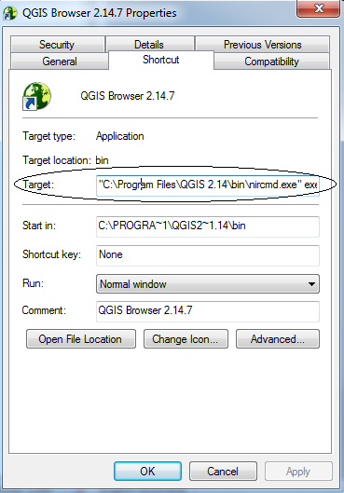
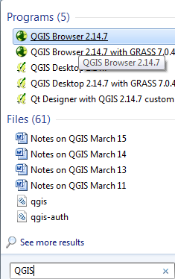

View ‘Target:’ which gives its location

Practise Exercises

Select By button / by form
By expression / filter by expression
By boundary / clip by boundary

Create layers Polygons Adjust format
Move
Create and remove nodes

Dots Adjust format
Map by category – making some disappear
Label and format labels
Create labels field & label by rule using labels field
Create a buffer zone

Label by Rule Using an expression eg: Geocode In (‘Cardinia’, ‘Casey’ etc)

Connecting addresses to map Look up addresses in PropertyNo layer, use expression to locate them, pin dots to them

Attribute Table (SA1 areas) Review add/delete feature, delete/add field, calculate field
Calculate a decimal field using ‘to-real’ function
Calculate a field using Case….End
Still on SA1 areas Add a field using the CSV file
Map areas by a field

Map Composer Create a map of the SA1 or SA2 areas map, above

For guidance in selecting ranges, use the “Percentile Calculator”. If a high proportion of values in a field are zeros, you may have to use the deciles as a guide to create a single lower range to encompass the zero values, with positive values for the other ranges.

